The Environment for Development initiative is a capacity building program in environmental economics focused on international research collaboration, policy advice, and academic training. It consists of centers in Central America, Chile, China, Colombia, Ghana, Ethiopia, India, Kenya, Nigeria, South Africa, Sweden, Tanzania, Uganda, Vietnam, and the US (Resources for the Future). Financial support is provided by the Swedish International Development Cooperation Agency (Sida) through the University of Gothenburg.

Locating Marine Protected Areas for Turtle Conservation: Understanding Ecology and Fishers

By H. Jo Albers
April, 2020

The Convention on Biological Diversity’s Aichi Targets include target goals of setting aside a percentage of marine areas as marine protected areas (MPAs). One purpose of marine protected areas is to protect species such as sea turtles from fishing. Fishing can accidentally catch turtles and can disrupt the turtles’ progress to the beach for laying eggs. This research demonstrates that more conservation of biodiversity occurs for a given MPA area when the specific configuration, location, and enforcement of the MPA reflect both the ecological characteristics of the protected species and the economic decisions of fishers. Motivated by Central American sea turtle conservation, this research focuses on the conservation of sea turtles through the use of MPAs that restrict fishing in places where fishers accidentally catch sea turtles and disrupt the turtles’ progress to the beach for laying eggs.

With many countries seeking to increase the area conserved in marine protected areas (MPAs) to achieve the Convention on Biodiversity’s Aichi Targets by 2020, we employ a bio-economic model to determine which configurations of MPAs that meet various area targets perform the best for achieving a secondary goal of protecting sea turtles. To produce conservation benefits and to make sure the protected area is not just a “paper park”, MPA managers patrol and enforce fishing restrictions within the MPA. Some MPAs are “no-take reserves:” no fishing is legal. Other MPAs may permit fishing but enforce the use of turtle exclusion devices. In either case, most countries have MPA enforcement budgets that are too small to deter all illegal fishing activities.

Key Points:
- For the same target area of a Marine Protected Area, more turtle conservation results from choosing MPA locations that take into account fisher decisions and turtle biology.
- Given budget constraints for enforcement activities, in some cases, more turtle conservation can be generated by smaller MPAs.

Because the conservation of sea turtles requires limiting the negative impact of fishing activity on those turtles at sea, our framework incorporates fisher location and effort decisions in reaction to the MPA configuration and enforcement. In addition, the framework considers two critical locations in the sea turtle life cycle that MPAs can affect: first, feeding and breeding locations offshore where sea turtles spend significant amounts of time but where by-catch (unintended catch) occurs; and second, the nearshore sea “corridor” to the beach on which sea turtles lay eggs in their habitual locations. Many sea turtles have a strong preference – strong fidelity – to lay their eggs in a narrow area of the beach on which they hatched, with little variation, after migrating through forage, breeding, and nearshore “inter-nesting” areas for several years.

We investigate a policy that is common, including in the Convention on Biodiversity, of focusing on establishing protected areas as a percentage of the land or marinescape rather than establishing a goal relating to the species. Here, we consider how best to achieve different marinescape area goals in addition to maximizing the protection of turtles as an additional goal. We consider different levels of budget to enforce fishing restrictions within the protected area; with too little enforcement, fishers continue to fish in the protected area and turtles are not protected from fishers’ nets and lines. For example, with an area target of 33% of a marinescape and with high enough enforcement budgets to induce fishers to reduce fishing in the protected area, it works best to locate MPAs in the near and off-shore areas that lead directly to the turtle’s preferred egg-laying beach. At lower budgets, however, the level of enforcement does not change fishers’ decisions about where to fish, which reduces the conservation of turtles in those migratory corridors to the beach. For example, if the turtles’ preferred beach is located close to a fishing port, that MPA pattern may not produce much turtle protection because high levels of enforcement will be required to discourage fishers from fishing close to their port. In those cases, placing the MPA in positions that provide fish dispersal to sites whose higher fish stocks attract fishers to those sites and away from critical turtle locations, is preferred to low levels of enforcement in MPAs in the entire turtle corridor. In cases in which the MPA’s mechanism for creating the turtle conservation benefits relies on reducing fishing effort and on displacing it away from turtles, failing to consider how fishers will react to lightly enforced MPAs leads to ineffective configurations for the MPA. On the other hand, recognizing fishers’ reaction can dramatically improve turtle conservation while still meeting area targets for MPAs.
Key Ecological Characteristics of Sea Turtles
Protecting sea turtles with MPAs requires an understanding of key biological and ecological characteristics of the sea turtle life cycle, particularly sea turtles’ three primary activities: Breeding, Migrating, or Nesting. In considering the locations of MPAs, the first step is to identify the sites of each sea turtle activity in the region.

Because the seven species of sea turtles are highly mobile, most sites will have one species of turtles undertaking only one activity, although some sites can have different species and activities occurring (e.g., Bocas del Toro in Panama hosts Leatherback, Hawksbill, Green, and Loggerhead turtles).
For ecological conservation impact, the MPA location must account for the time spent in, and risks associated with, each type of turtle behavior. For example, an MPA in a site in which turtles breed needs protection from fishing only during the breeding season. Similarly, turtles face lower risk during the 90% of their lifecycle spent feeding, but risks differ depending on the feed source, such as grasses versus sponges near reefs.

In settings where the government meets country-wide area targets by putting an entire coastal region into an MPA, the level of enforcement and the reaction of the fishers again determine the level of turtle conservation achieved. If the budget is spent equally everywhere, the level of enforcement may be too low to deter fishing in critical turtle locations, and thus there will not be much turtle conservation, despite the large MPA size. At all but very high enforcement budgets, appropriate configurations of MPA sites covering one-third to one-half of the marinescape have high enough enforcement levels to generate higher levels of sea turtle conservation, compared to a large but poorly enforced large MPA.

Conclusion. Marine protected areas achieve sea turtle conservation by enforcing restrictions on fishers to limit fishing’s impact on turtle populations through accidentally catching the turtles and through disrupting migratory progress to the beach for egg-laying. However, most managers have small and limited budgets available to enforce fishing restrictions. That limited budget can be applied to protect turtles in locations that are critical at certain stages in the turtles’ life cycle. When designating the MPA and deciding how to focus enforcement, it’s also important to think about the fishers’ reactions to the location and enforcement of the MPA; if this fisher response isn’t taken into account, the highest turtle conservation benefits won’t be achieved. In addition, at low to moderate enforcement budgets, the emphasis on achieving large areas of MPAs leads to lower levels of sea turtle conservation than smaller MPAs.

Further Reading
Albers, HJ, L Preonas, R. Madrigal, EJZ Robinson, S. Kirama, RB Lokina, J Turpie, and F Alpizar. 2015. “Marine Protected Areas in Artisanal Fisheries: A Spatial Bio-economic Model Based on Observations in Costa Rica and Tanzania.” Environment for Development Discussion Paper Series. EfD DP 15-16. July.
Albers, HJ, R. Madrigal, S. Kirama, RB Lokina, A Hepelwa, EJZ Robinson, J Turpie, and F Alpizar. 2015. “Marine Protected Areas: Lessons from Costa Rica and Tanzania.” Environment for Development Research Brief 15-16. July 22, 2015.
Albers, HJ, T Capitan, R Madrigal, and B White. 2019. Siting Marine Protected Areas in Artisanal Fisheries with Aicha Area Targets: Protecting Rural Incomes, Fish Stocks, and Turtles. EfD Discussion Paper, forthcoming.
Carr, Archie. 2011. So excellent a fishe: A natural history of sea turtles. University of Florida Press. 256 pp.
Madrigal, R; Schlüter, A; López, M C. 2013. What makes them follow the rules? Empirical evidence from turtle egg harvesters in Costa Rica. Marine Policy, 37, 270–277.
Madrigal-Ballestero, R., H.J. Albers, and Capitán, T. 2017. Marine protected areas in Costa Rica: How do artisanal fishers respond? Ambio, 46(7): 787-796
Madrigal-Ballestero, Róger and Jurado, Diana. (2017). Economic Incentives, Perceptions and Compliance with Marine Turtle Egg Harvesting Regulation in Nicaragua. Conservation and Society. 15. 74-86. 10.4103/0972-4923.201392.

A Tale of Two Turtle Populations in Costa Rica

Tortuguero National Park | Ostional Wildlife Reserve
Tortuguero in Costa Rica is the main nesting site for Green Turtles in the Caribbean. Ever since the father of turtle conservation, Archie Carr, started tagging projects back in the 60s, Tortuguero has been a hub for sea turtle research and conservation efforts. Those efforts have paid off with the number of turtles nesting in Tortuguero every year now higher by an order of magnitude than back in Archie’s days. In addition, Tortuguero’s tourism industry centers on guided tours to see sea turtles, which has driven wages in Tortuguero far higher than in the neighboring town of Barra del Colorado. Instead of relying on fishing income, people in Tortuguero rely on higher-paying jobs in the tourism sector. This eco-tourism development means that there are the same incentives for turtle conservation and livelihoods. | Ostional on the Pacific coast of Costa Rica is the site of a major “arribada” or mass arrival of Olive Ridley Sea Turtles to lay eggs. The Costa Rican government enforces regulations against the harvest of all sea turtle eggs but, due to the abundance of eggs and the damage late-arriving turtles do to eggs laid earlier, a community organization has permission to harvest and sell some eggs in exchange for members performing conservation activities throughout the year. Those activities include acting as tour guides during arribadas, and other tourism-related businesses such as restaurants have grown in the area. The community organization and the related tourism have created economic opportunities for people that are tied to conservation of Olive Ridley turtles.
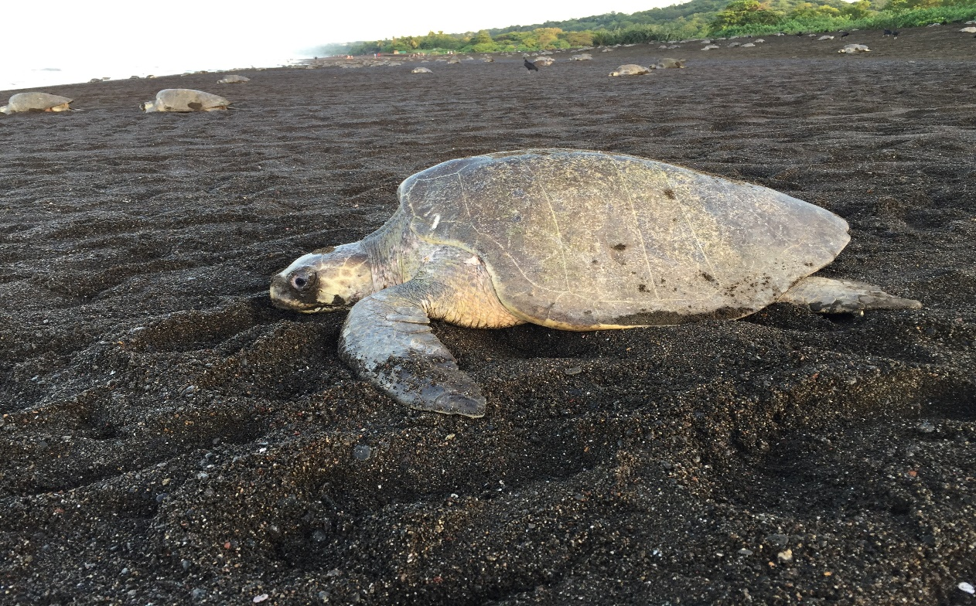

This brief is based on “Name of Discussion Paper,” EfD Discussion Paper Series 20-xx, by First Name Last Name, First Name Last Name, and First Name Last Name.

Contact: (name, institution, and email)

Environment for Development Initiative
Www.efdinitiative.org
Info@efdinitiative.org
University of Gothenburg
Gothenburg, Sweden

