|  |
| --- |
| **The Environment for Development initiative is a capacity building program in environmental economics focused on international research collaboration, policy advice, and academic training. It consists of centers in Central America, Chile, China, Ethiopia, Ghana, Kenya, Nigeria, South Africa, Sweden (University of Gothenburg), Tanzania, Uganda, and the US (Resources for the Future). Financial support is provided by the Swedish International Development Cooperation Agency (Sida).** |

The Jigsaw Puzzle of Chinese Fisheries:

Sustainability Comparisons in Community, Economic and Environmental Performance

Lijun Liu, Jingjie Chu, James L. Anderson, and Jintao Xu

January 19, 2021

By comparing Chinese fisheries with the world’s top-performing fisheries, we look for what the Chinese fisheries have been doing well and where improvements are needed.

China is the largest fishing nation in the world and a key player in the international seafood trade. But how well Chinese fisheries are performing has remained a puzzle. Who are the fishers? What are they catching? Where are the fish sold to? How are the fisheries managed? What can be done to improve the managerial efficiency? Curious about these questions, EfD China launched its first fisheries research program using the Fishery Performance Indicators (FPIs) to evaluate the triple bottom line (ecological, economic, and community sustainability) of four Chinese fisheries in Zhejiang Province, China.

Key Points

* This paper evaluates the performance of Chinese fisheries management compared to top performing fisheries in the world.
* It gives insights into the reforms and policy changes that China is making to improve its fishery management. This is especially important given the fact that China is the largest seafood producer, the largest seafood exporter, and the third largest seafood importer by value.
* China's policy changes will affect both its domestic and global fisheries' ecological, economic and community sustainability.

The FPIs are a set of rapid assessment indicators designed to capture the ecological, economic, and community features of individual fisheries and their enabling conditions. Each assessment includes 68 output indicators and 54 indicators on enabling factors. An assessor needs to score each of the indicators with a score from 1 to 5 based on best knowledge available, i.e., both data and expert opinions.

The four fisheries assessed by EfD China focused on specific species (swimming crab, hairtail, mackerels) or fishing gear employed (shrimp trawl) in Zhejiang Province, China, with a reference year of 2017. They were assessed through comprehensive desktop research as well as multiple field trips, one workshop hosted by EfD China and dozens of workshops we attended, interviews with government officials, industry leaders, community representatives, and researchers of Chinese marine fisheries biology, ecology and policies.

Upon completion of these assessments, new questions were raised. How are Chinese fisheries doing in comparison with other fisheries, especially the world’s top fisheries and fisheries in other parts of China? The former comparison could tell us what the Chinese fisheries have been doing well and where improvements are needed and the latter helps us identify potential differences by place and time.

To address these questions, we compared nine Chinese fisheries (four contributed by EfD China and five by other researchers) with the top 10% performing fisheries within the global FPIs database and then compared the four Zhejiang fisheries with the other 5 fisheries from other regions along the Chinese coastline. The results show the largest differences between the Chinese fisheries and top-performing fisheries globally are in ecological sustainability, followed by harvest sector performance and economic performance. The gaps in community sustainability and post-harvest performance are smaller.

Compared to other provinces, Zhejiang shows signs of better fishery management, with its stronger enforcement and stricter measures to tackle illegal fishing and, as a result, higher scores in ecological and some economic and social dimensions.

**Conclusion:**

China is the largest seafood producing country in the world and has a national objective to improve fisheries management. We compared performance of nine Chinese fisheries with the top 10% performing fisheries in the global FPI database for the three pillars of sustainability as well as harvest and post-harvest performance. All measures indicate that there is a significant room for China to improve. The comparison with the top performing fisheries globally helps identify where the improvements are needed. Input factors such as strengthening harvest rights, stronger fishery community participation and leadership, improved management capacity (enforcement), management methods (setting Total Allowable Catch and regulating where fishing can take place), as well as data collection and analysis and better market institutions, are all areas that, if improved, are likely to strengthen China’s fishery management systems towards triple bottom line sustainability.

In recent years, China has committed to a new national strategy, namely the ‘Ecological Civilization’ as a response to China’s environmental degradation and global crises such as climate change. As part of this national transformation towards environmental sustainability, fishery and aquaculture management authorities have started putting more effort into balancing development and ecological conservation. The administration has gradually shifted its goals from quantitative growth to quality and efficiency improvement. A series of reform actions have been taken to push the institutional change to better defined fisheries management based on assigning fishing rights so that fishers have an incentive to manage the fishery sustainably. Will China’s plans to reform fisheries help China approach the best managed fisheries in the world? We hope that this research will be used as a baseline for future assessments of the effectiveness and efficiency of such reforms.

About this brief

This research brief is based on “Sustainability Comparisons in the Triple Bottom Line for Chinese Fisheries” (January 2021). EfD Discussion Paper Series 21-01, by Lijun Liu, Jingjie Chu, James L. Anderson, and Jintao Xu

Further reading

Anderson, J. L., Anderson, C. M., Chu, J., Meredith, J., Asche, F., Sylvia, G., ... & McCluney, J. K. (2015). The fishery performance indicators: a management tool for triple bottom line outcomes. PLoS One, 10(5), e0122809.

Su, S., Tang, Y., Chang, B., Zhu, W., & Chen, Y. (2020). Evolution of marine fisheries management in China from 1949 to 2019: How did China get here and where does China go next? Fish and Fisheries, 21(2), 435-452.

Contact

Lijun Liu, [lijunliu.06@gmail.com](mailto:lijunliu.06@gmail.com), Peking University, Beijing, P.R. China

|  |  |
| --- | --- |
| logo_efd_cmyk | Environmental Economics Program in China (EEPC), National School of Development, Peking University, Beijing, PRC, www. <https://efdinitiative.org/china> [yinhang841@hotmail.com](mailto:yinhang841@hotmail.com)  Environment for Development Initiative, [www.efdinitiative.org](http://www.efdinitiative.org) [info@efdinitiative.org](mailto:info@efdinitiative.org)  University of Gothenburg, Gothenburg, Sweden |
|  |  |

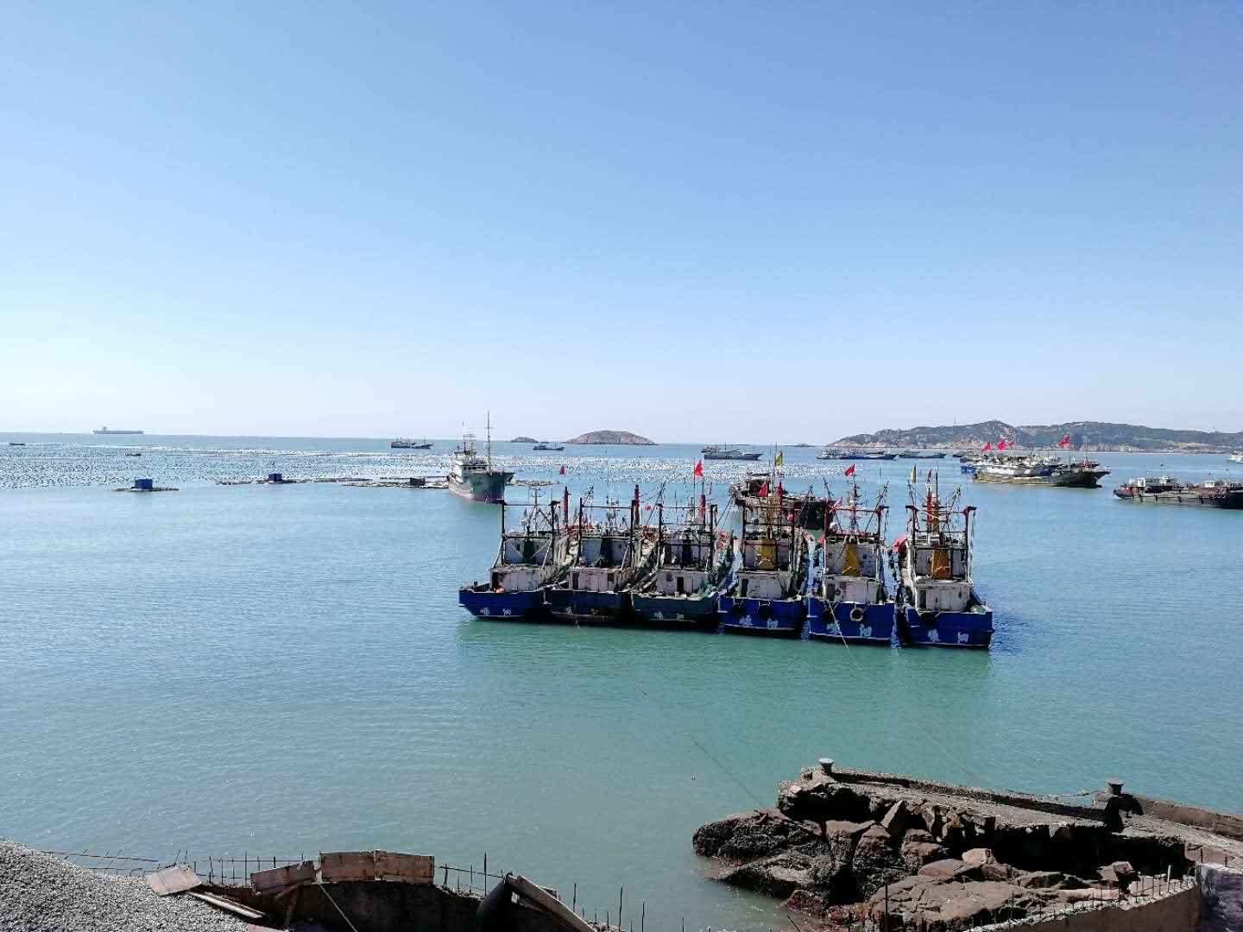

Figure 1 October 9, 2019. The gillnetters participating the swimming crab total allowable catch (TAC) pilot program are waiting to enter the fishing ground in the Shengsi islands. Photo credit: Lijun Liu