CHANGES IN LAKE VICTORIA’S HYDROLOGY, WATER QUALITY, AND LIVELIHOODS

EfD-MAK POLICY BRIEF NOVEMBER 2020

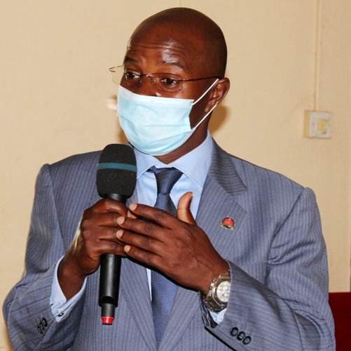
Executive Summary
Lake Victoria is a transboundary natural resource, underpinning the economies and livelihoods of the people within the wider catchment area of Burundi, Kenya, Tanzania, Rwanda and Uganda. The lake acts as a source of fresh water, fishing, tourism, a waste repository and provides food, energy, water for drinking, irrigation, industry and for within and cross border transportation. However, the lake and its surrounding areas are facing many challenges including rising lake water levels, floating islands-resulting from human encroachment on its banks, declining fish stocks, ecological and biodiversity degradation. It is upon this background that Environment for Development Initiative Centre (EfD-Mak Centre) based at Makerere organized a series of policy dialogues on changes in Lake Victoria hydrology, water quality and livelihoods in Uganda’s lake basing districts of – Jinja, Masaka and Bugiri. During these dialogues, it was noted that the Lake’s buffer zone requirement of 200 meters set by the National Environmental Management Authority (NEMA) has been widely violated resulting in severe encroachment on the lake by the farmers, illegal fish mongers, hotels and beaches, industries and settlers. The intensity of such human activity has contributed to soil erosion resulting in the sedimentation of the lake. Polythene bags, plastics and untreated waste also continue to pollute and damage the lake’s water quality and are an existential threat to its aquatic life. Political interference, poor fishing methods, inadequate lake monitoring and poor implementation of the existing laws on the management and utilization of the lake were noted as key factors perpetuating the lake’s degradation. During the several sessions, stakeholders resolved that there should be argent involvement and mass sensitization of the local communities around the lake on issues of sustainable management and use of the lake, deepening transboundary cooperation and regulation of the lake activities, tackling both point and non-point source pollution including designing a coherent action plan for conservation and rehabilitation of the Lake’s ecosystem. NEMA, Uganda’s environment watchdog together with the relevant authorities at the different levels of government should ensure that the lake buffer zone is observed through active regulation of socioeconomic activity around the lake. In addition, programs aimed at restoring and conserving wetlands, grasslands and forests in the lake catchment areas must be prioritized.

Introduction and Motivation
The Lake Victoria Basin (hereinafter, the basin) is a critical transboundary natural resource, supporting the economies and livelihoods of the people within the wider catchment area and acts as a waste repository and provides food, energy, tourism, water for irrigation, drinking industry and transport services. The basin has a total area of 194,200 Km² and is shared by Burundi, Kenya, Rwanda, Tanzania, and Uganda. A population of approximately 45 million people lives in the basin, with roughly 80% of it, reliant on rain-fed agriculture for its livelihood. According to Awange et al. (2014), more than 200,000 fishermen and their families depend on daily fish catches for their basic needs. The fishing industry is estimated to directly employ more than 800,000 people in the basin and contributing about 2 to 3% of the basin’s GDP. Being the source of the river Nile, the lake also supports the livelihoods of Egypt, Ethiopia, South Sudan and Sudan. Moreover, it is the primary modulator of the great lakes region’s climate (Njiru et al., 2008). Despite its importance, the basin has and is still undergoing severe environmental degradation resulting into significant ecological and economic challenges. From an ecological perspective, the lake has experienced profound ecological degradation which is evident in the probable extinction of several species of endemic fishes. An average loss of 10.8% in species richness has been reported (Soesbergen et al., 2019). Rapid population growth, agricultural expansion, urbanization, poor physical planning and industrialization have mounted extreme pressure on the lake and its basin’s ecosystems, and have led to the degradation of lands and the loss of wetlands and forests around the lake. In addition, terrestrial biodiversity has been adversely affected by the loss of natural habitats. Insufficient monitoring and weak enforcement of regulations on illegal- and over-fishing activities on the lake have reduced fish stocks, threatening crucial livelihoods and food security. Water pollution from both the point- and non-point sources such as human settlements, industries and agricultural activities and other land use forms in the watersheds has contributed to a reduction in water quality and caused eutrophication, with its attendant consequences for aquatic life. In some sub-catchment areas, the nitrogen load is as high as 1000 kg/Km²/year due to unsustainable land use practices and soil erosion. As a result, the water hyacinth- a notorious invasive species affecting fishing, water quality and waterway transport has rapidly spread in many locations of the lake.
KEY MESSAGES
Lake Victoria Basin is facing a number of challenges:
- Ecological and biodiversity degradation.
- Declining fish biomass catch and exports.
- Rising water levels and moving islands.
- Untreated and poorly disposed wastes.
- Lake sedimentation due to catchment and buffer zone encroachment.
- Reducing business activity along the lake shorelines leading to poverty, Unemployment and high crime rates.
- Infrastructure, power and transport disruptions.
- Encroachment of the surrounding wet lands such Lwera and forests such as Mabira and Wakawaka.
- Disbandment of beach management units.
The following are measures that would strengthen sustainable management and use of the Lake Basin ecosystem services:
- Empowering the local communities and media to protect the lake basin, biodiversity and ecosystem.
- Effective regulation of all the lake activities including fishing and waste disposal.
- Managing the lake basin jointly as a transboundary resource.
- Efficient enforcement of the existing laws such as the 200m buffer zone away from the lake.
- Finding alternative land for industries away from the lakes, rivers, forests and wetlands.
- Incorruptible, efficient, skilled and well equipped lake regulatory body to effectively monitor all activities on the lake.
- A coherent plan for conservation and rehabilitation of the lake fish fauna.
- Restoration of the degraded wetlands and forests within the basin.

The policy dialogues
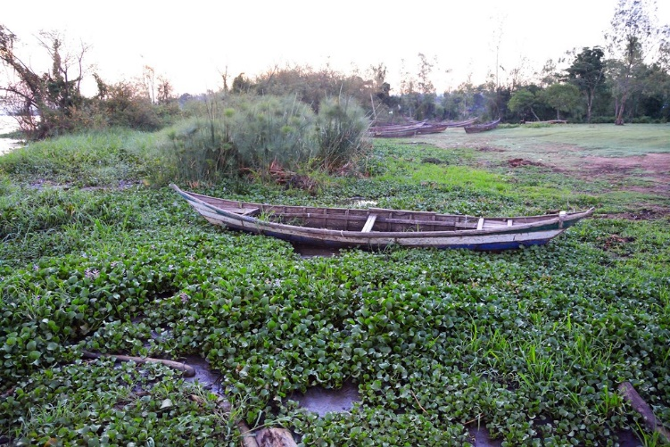
A section of Lake Victoria covered by the water hyacinth.
Three policy dialogues on the subject matter were organized in the Districts of Jinja, Masaka and Bugiri in August, September and October 2020, respectively. The dialogues attracted the district leaders including politicians, the chief administrative officers, the district environmental and natural technical staff, civil society, the representatives from the basin’s community, officers from the environment protection police unit and media practitioners. The goal of the policy dialogue was to discuss and brainstorm on the changing status of the Lake’s hydrology, water quality, livelihoods and other challenges facing the management and utilization of the Lake so as to identify the possible solutions to mitigate environmental degradation around the basin. The district chairpersons of Jinja, Masaka and Bugiri noted that the lake is faced with increasing encroachment from investors and all manner of industrialist activity aided in many instances by powerful politicians and business men to acquire land titles in the lake’s buffer zones and its surrounding, forests and wetlands. They gave examples of encroachment on Kirinya and Lwera wetlands, Mabira and Wakawaka forests among others. The chairpersons blamed both the central and district local governments surrounding the lake for negligence and slow action that has resulted in encroachment of the lake’s buffer, the catchment area and pollution. The lake is increasingly experiencing sedimentation which, combined with its natural shallowness risk causing its extinction if the current trend is not reversed. In terms of policy formulation and implementation, it was observed that although Uganda boasts of good laws, implementation of such laws and policies remains weak. This is mainly due to inadequate funding of the regulatory bodies, inadequate capacity and equipment to use in the monitoring of the lake, corruption and lack of coordination among Lake Basin countries. The representatives of the local communities around the lake decried the lack of their involvement in the management of the lake, design and implementation of the lake’s regulatory laws and policies. They protested the disbandment of the Beach Management Units (BMUs), which to them was playing a big role linking the regulators to community. They contended that disbandment of BMUs created a big gap between the lake users and regulators. They also argued that lack of sensitization on sustainable use of the lake among its users, unequal application of the law and corruption among the law enforcers have facilitated the lake’s degradation, illegal activities in and around the lake and illegal settlements. The participants also noted that degradation of the lake and encroachment on its catchment area have led to lake sedimentation due to soil erosion. Unregulated fishing had resulted in a sharp reduction in the fish catch leading to unemployment and loss of business and government revenue from fish exports. According to the Director EfD-Mak Centre, climate change has also affected the lake basin as temperatures have consistently increased between 0.1°C and 2.5°C, based on historical data from 1920 to 2013. According to Seema and Oppelstrup (2020), projections for rainfall are more uncertain and vary between seasons, with some models showing increased rainfall while others show decreased rainfall totals. The basin and its inhabitants are vulnerable to the increasing effects of climate shocks, which would likely exacerbate its environmental problems as witnessed recently with water overflows and moving islands on the lake. The basin has a history of floods and droughts, with short and long-term consequences for communities. Such extreme events worsen environmental problems such as land degradation and deteriorated water quality. Increased rainfall variability and changes in the timing of the rainy seasons affects agricultural production and places more pressure on natural resources and drive further encroachment of wetlands and other environmentally sensitive areas through climate-change induced migration. In recent decades, some of the rivers and streams serving the lake and its near-shore areas have become particularly polluted by partially treated municipal waste, industrial effluents, urban surface contaminated runoff, and raw sanitary effluent from human settlements. Most lake nutrients originate from organic and inorganic wastes from intensive agricultural activities, municipal sewage, and livestock carried by rivers into the lake. This is worsened by the malfunctioning sewage plants which inadequately treat sewage. The plastic waste, agricultural and chemical industries discharge pollutants including soils directly into the lake. On the Tanzanian side of the lake for example, small-scale gold mining activities were observed to have increased potential sources of heavy metals, pesticides and nutrient-rich effluents into the lake (Khaki and Awange, 2019). Heavy metals originating from urban settlements and remote inland areas, food processing, textile, leather, paper production, and metallurgy industries in Jinja as well as pollution from Murchison Bay have adversely affect Uganda’s side of the lake. While wetlands are natural water purifiers, much of the lake’s wetland cover has been lost over the years due to unregulated human activity. There has been progressive degradation of the catchment area through farming, deforestation, overgrazing, human settlements and forms of socioeconomic activity. These has caused transportation of sediments, and other pollutants into the lake’s ecosystem due to the removal of the buffering effect of the wetlands’ macrophytes. There is the need for quick action to protect the basin’s biodiversity in order to safeguard the communities’ welfare which is at stake. This calls for putting into place measures to ensure sustainable use of the lake, said the Director EfD-Mak Centre.
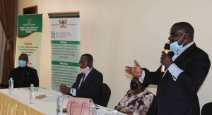
LCV Masaka district local government, Mr. Jude Mbabaali addressing the participants.

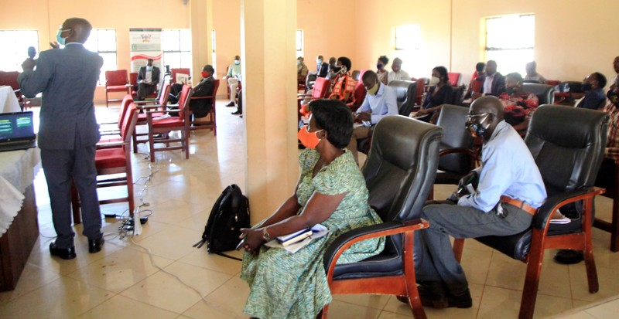
A section of participants attentively listening to Prof. Edward Bbaale, Director EfD Mak Centre.

Measures for sustainable management and use of Lake Victoria Basin
Bugiri District Police Commander ASP Ssebuyungo, addressing EfD Policy Participants on 29th Oct, 2020.

From the dialogue, the following were proposed as measures to ensure efficient and sustainable management and use of Lake Victoria: Protection, preservation and restoration of Lake Victoria biodiversity should become part of an integral lake basin plan. Particularly, the influence of upstream activities on the Lake should be proactively regulated and the guidelines for controlling nutrient influx and fishing pressure established and implemented through both sensitization, dialoguing and strict enforcements of the law. Any attempt to conserve habitats and biodiversity in the lake will succeed only if the general environmental quality permits. Efforts to ensure this should include maintenance and restoration of water quality in the lake, its tributaries, and the associated wetlands. The lake basin Local governments should formulate and pass ordinances and bi-laws to protect the lake basin. There is the need for a biological monitoring system based on elements of the indigenous flora and fauna of the lake including fish stock management strategies to prevent depletion of some fish species. The same should be done to other lakes such as Albert and Kyoga among others. To curtail the pressure on the lake’s fish stock, fish farming should be widely encouraged. The maintenance of wetlands in the basin is critical for both ecosystem services and conservation of indigenous species. This should be followed by economic valuation of all lakes, rivers, wetlands and other natural resources in the country. Transboundary cooperation on the Lake Victoria Basin management and tackling of both non-point source pollution through sustainable land and water management and sustainable fisheries and lake management, and point source pollution through improved municipal wastewater and sanitation management and industrial pollution control need to be enforced. A coherent plan for conservation and rehabilitation of the lake; fish fauna should be developed. The plan should entail provisions for halting and reversing eutrophication and for setting up reserves that typify the various habitats of the lake and its tributary rivers, associated wetlands, and satellite lakes. It must also consider the human aspects of such reserves through consultation with local groups. The plan should be incorporated into more general policies for the management of the fishery and for the wide range of other human activities in the lake basin. The local community and local leaders should be empowered and involved by the authorities in the protection of the lake from destruction and bad fishing practices. Massive campaigns about proper disposal and treatment of both liquid and solid waste in eco-friendly way should be encouraged. The buffer zone size of 200m away from the lake should be emphasized and strictly enforced and there should be urgent mapping of flood risky areas/zones of the lake so as to adjust the buffer sizes where necessary. There is also a suggestion to have an independent body to manage the lake. However, the fishing community and the communities around the lake including local leaders should be actively involved in management and conservation of the lake. The fight against climate change should not be ignored and thus the government should launch a plan to plant trees along all roads and also native shrubs/trees along all the lakes & river buffer boundaries in the country. For the socio-economic aspects, landing sites and communities especially those that were so much affected by recent floods, buffer zone evacuations and resettlements should be supported in terms of relief packages, because if not supported, these people are most likely to re-encroach the protected zones.
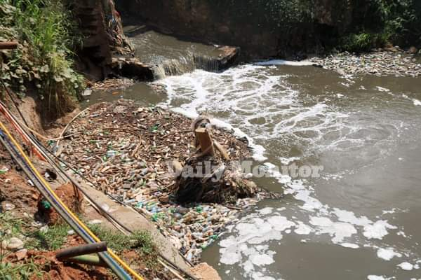
A section of the Nakivubo drainage channel in Kampala piled with plastic waste. The channel ends directly into Lake Victoria pausing a threat to aquatic life (Daily Monitor, June 23, 2020).

Conclusion

Nature is talking and thus, we need to listen. “Humanity can forgive and forgets but mother nature neither” said Pope Francis II, which implies that nature destruction has far reaching consequences. Effective management of Lake Victoria Basin requires participation of all stakeholders, local leaders and the community in the basin and all Lake Basin countries. The ongoing degradation and pollution of the lake should be treated as an emergency case just as the COVID-19 pandemic to ensure that the lake biodiversity, ecology, species and boundaries are protected. The government should take lead in sensitizing the masses, training environmental policy makers and regulators and media on the importance of conservation and sustainable use of Lake Victoria. In addition, the government should increase its budget allocation to the environmental and natural resources’ sector and ensure that the sector is well equipped with skilled, capable and incorruptible human resource and monitoring equipment.

Acknowledgement

The policy brief was written by Peter Babyenda and edited by Dr. Nick Kilimani on behalf of EfD Makerere Centre, Uganda.

References
Awange, J.L., Gebremichael, M., Forootan, E., Wakbulcho, G., Anyah, R., Ferreira, V.G., and Alemayehu, T. (2014). Characterization of Ethiopian mega hydrogeological regimes using GRACE, TRMM and GLDAS datasets. December 2014. ISSN 0309-1708. Adv.Water Resour. 74, 64 - 78.
Khaki, M., and Awange, J. (2019). Improved remotely sensed satellite products for studying Lake Victoria’s water storage changes. Science of The Total Environment, 652, 915 - 926.
Njiru M., John Gichuki, Charles Ngugi and L. Muhoozi. (2008). An overview of the current status of Lake Victoria fishery: Opportunities, challenges and management strategies. Lakes & Reservoirs: Research and Management 2008, 13: 1–12.
Seema, P., and Oppelstrup, J. (2020). Hydro-meteorological processes driving solute transport in Lake Victoria, Water Science, 34:1, 18-31.
Soesbergen, A., Sassen, M., Kimsey, S., and Hill, S. (2019). Potential impacts of agricultural development on freshwater biodiversity in the Lake Victoria basin. Aquat. Conserv. Mar. Freshw. Ecosyst. 29, 1052–1062. https://doi.org/10.1002/aqc.3079.

