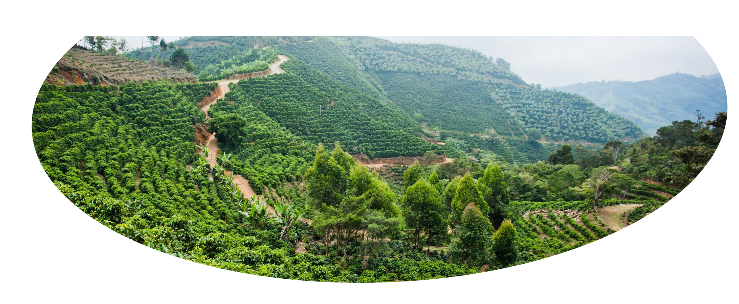

Policy Brief
Environment for Development
20-01-2026
Kampala, Uganda
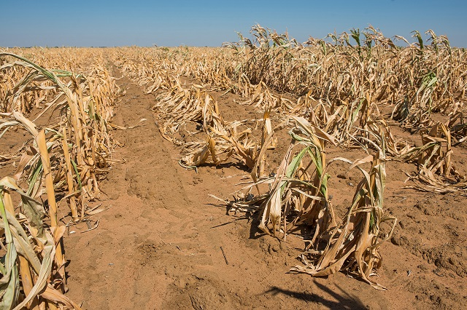

Figure/picture
The problem
Agriculture remains the backbone of Uganda’s economy, contributing about 23.8% to GDP and employing about 68% of the working population in activities such as cropping, forestry, livestock, and aquaculture, among others (UBOS, 2024). The sector also provides essential raw materials to drive the nation’s value-addition agenda under the Agro-industrialization program, as articulated in the Fourth National Development Plan (NPA, 2025). However, climate change and climate variability now pose significant threats to the sector with implications for food and nutrition security and the overall livelihoods of millions (Babyenda et al., 2023). Furthermore, those changes threaten the country’s goal of tenfold growth by 2040. This is because over 96% of farming households rely on rainfed smallholder agriculture, rendering the sector highly vulnerable to climate change and climate variability (Twecan et al., 2022).

Background and context
The unpredictable shifts in climatic patterns and limited adaptive capacity are adversely affecting agriculture and, in turn, the livelihoods of the Ugandan population (UBOS, 2024). To this end, the Government of Uganda, through the Ministry of Agriculture, working with other ministries, including the Ministries of Water and Environment, Energy, and Finance, has promoted the uptake of Climate-Smart Agriculture (CSA) (Zizinga et al., 2022).

CSA practices, e.g., conservation agriculture, improved seed varieties, water conserving irrigation, agroforestry, and integrated pest management, can increase productivity, strengthen resilience to climate change, and reduce greenhouse gas emissions. However, despite the potential long-term benefits, CSA uptake remains low. This policy brief summarizes key evidence, stakeholder views, and practical recommendations to accelerate CSA adoption.
Policy recommendation
To promote widespread adoption, there is a need to invest in agricultural extension services to educate farmers on the implementation and associated benefits of CSA, to design an inclusive policy framework and or policy incentives that ensure active participation of especially women and youth, to establish more localized, context-specific partnerships to effectively promote CSA, and to support farmer training and awareness campaigns.

Scaling up Climate Smart Agriculture (CSA) adoption in Uganda: Barriers and policy options

Edward Bbaale, Peter Babyenda, John Sseruyange, Nicholas Kilimani, Thomas Epeek, Nicholus Magara, Irene Kemigisha, Boaz Tumusiime Mboijane, and Gertrude Basiima


Please get in contact with us if you want more information about this policy brief.
Contact person: pbabyenda@gmail.com
efdinitiative.org

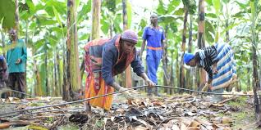

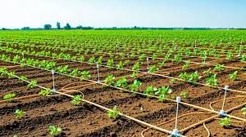

Challenges
While strides have been made toward incorporating climate change interventions into national development plans, agricultural policies, and programs that could lead to the adoption of CSA practices, several barriers remain. These include:

A gap between technology suppliers, who are largely based in urban areas, and end users (rural farmers). This gap is further widened by inadequate and overstretched extension services.

Centralized meteorological infrastructure, which limits the availability of timely, localized weather information. Strengthening regional meteorological services can deliver localized forecasts and early warnings, enhancing farmers’ climate resilience and decision-making.

Many CSA technologies primarily focus on increasing production. However, limited attention is given to post-harvest handling and market linkages.

On the demand side, affordability, farmer awareness, knowledge, and motivation to adopt new practices influence the likelihood of CSA adoption.

In addition, a ‘one-size-fits-all’ approach to CSA fails to account for important regional differences.

Opportunities and impact
Whereas an estimated 72% of the country’s land cover is dedicated to agriculture, only about 30% of farmers practice climate-smart agriculture. Based on our data, a variety of CSA practices have been promoted. These are in the form of adaptation, mitigation, or both, including rainwater harvesting and storage practices and technologies; irrigation practices and technologies; soil and water conservation practices and technologies; conservation agriculture; and agroforestry. In the livestock sector, climate-smart practices include greening of livestock farming systems, improved livestock breeds, enhanced feeding practices, improved grazing land management, and biogas integration. Given that livestock production is the largest contributor to agricultural greenhouse gas (GHG) emissions in Uganda, these and other CSA practices offer significant opportunities to mitigate agricultural emissions.

Key points
Widespread adoption of CSA practices shall entail:
- Capacity building and expansion of extension services;

- inclusive policy design to ensure active participation of women and youth;

- more localized and context-specific partnerships to effectively promote CSA;

-farmer training and awareness campaigns on the use and benefits of CSA.

References
Babyenda, P., Kabubo-Mariara, J., & Odhiambo, S. (2023). Climate Variability and Agricultural Productivity in Uganda.

National Planning Authority-NPA (2025). The Fourth National Development Plan (NDP IV).

Twecan, D., Wang, W., Xu, J., & Mohmmed, A. (2022). Climate change vulnerability, adaptation measures, and risk perceptions at households’ level in Acholi sub-region, Northern Uganda.

UBOS (2024). National Population and Housing Census. Final Report. Uganda Bureau of Statistics.

Zizinga, A., Mwanjalolo, J. G. M., Tietjen, B., Bedadi, B., Gabiri, G., & Luswata, K. C. (2022). Impacts of climate-smart agriculture practices on soil water conservation and maize productivity in rainfed cropping systems of Uganda. Frontiers in Sustainable Food Systems, 6, 889830.

