Does Traffic Congestion pose Health Hazards? Evidence from a Highly Congested and Polluted City
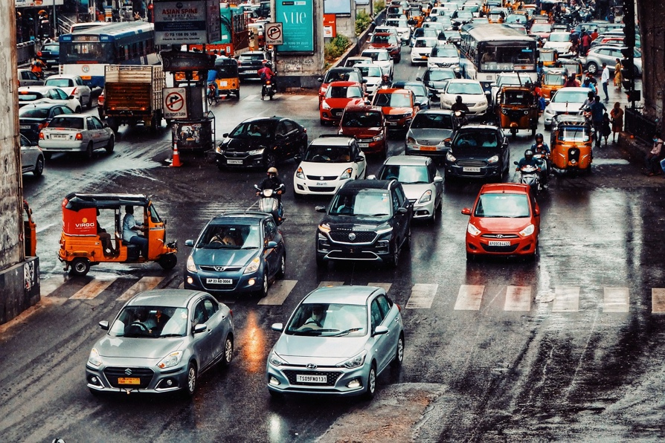  Traffic jam. Photo: Shivaphotography, Pixabay. | Highlights:  - Nearly 5000 deaths per year in Delhi can be attributed to traffic congestion.  - Increased traffic congestion worsens air quality. The worsening is greater when congestion is already at a high level.  - A congestion charge on large private vehicles can offer large benefits with minimal disruption to the existing status quo.
What is the issue?  Air pollution is a very serious problem in India whose severity has only worsened in recent years. Solving this problem poses a difficult challenge. The sources of air pollution are potentially many: electricity generation, construction, transportation, agricultural practices all play a role. It is not clear which sources are the most important, and therefore require most immediate action.  Recent evidence suggests there are very harmful health consequences from air pollution. Traffic congestion has also been found to influence health through increased air pollution. All this evidence, however, comes from countries whose air pollution levels are far lower than those of India. There is scant evidence regarding how traffic congestion affects air quality in India. As both exposure is high - the number of people breathing in polluted air in India is massive - and regulatory capacity is low (in terms of staffing, resources, or authority of local and central government authorities), filling in this knowledge gap is of the highest importance.  What do we do?  In our research, we focus on Delhi, one of the most polluted cities on the planet in terms of air quality. We identify the contribution of traffic congestion to air quality and simulate the health consequences of congestion. | Authors    Kanishka Kacker  Indian Statistical Institute, Delhi  kkacker@isid.ac.in    Ridhima Gupta  South Asian University, Delhi  ridhima@sau.int

Saif Ali
Indraprastha Institute of Information Technology, Delhi
saifa@iiitd.ac.in

How do we do this?

We analyse high frequency data using publicly released information on traffic congestion from Delhi for the year 2018. Then we include air pollution information – primarily PM2.5 – released from 36 monitors operated by the Central Pollution Control Board. Finally, using information on wind direction, we predict the impact of traffic congestion on air pollution concentrated around the monitors.

The figure below shows our estimated effects, at various levels of traffic congestion. At low to medium levels of traffic congestion, defined in terms of how a given level of traffic congestion ranks compared to others, we find little to no evidence of an impact. At high levels of congestion, however, a strong relationship exists. We use our estimates simulate the impact on deaths from heart and lung disease using results from the latest epidemiological literature.

This is the first comprehensive accounting of the impact of traffic congestion on air pollution for the city of Delhi. While in this application we restrict ourselves to Delhi, a major advantage of our model is that it can be applied to any city for which similar data exists. This opens vast possibilities of within and across country comparisons of how traffic flows might impact air pollution.

Implications for Policy:

Delhi is unique amongst cities in developing countries as all its public transportation runs on natural gas or electricity.

The major reason why congestion adds to pollution cannot be because of fuel use. Rather it is too much traffic at certain points of time: the contribution to pollution doubles when traffic is in the top 5% in terms of congestion.

A congestion charge has the potential to move traffic from more to less congested times. If it is levied on large private vehicles, the distributional impact will be minimal while the potential gain from avoided pollution is large.

Maps of Delhi showing levels of traffic congestion (top) and pollution concentration (below). Each polygon is a ward, the lowest political level of administration in Delhi. Only wards containing a monitoring station are coloured. Green indicates the lowest level and red indicates the highest. Wind blows prominently from the North-Eastern direction, which is why the south and east are most polluted despite not having the highest levels of congestion.
