|  |
| --- |
| **The Environment for Development initiative is a capacity building program in environmental economics focused on international research collaboration, policy advice, and academic training. It consists of centers in Central America, Chile, China, Colombia, Ghana, Ethiopia, India, Kenya, Nigeria, South Africa, Sweden, Tanzania, Uganda, Vietnam, and the US (Resources for the Future). Financial support is provided by the Swedish International Development Cooperation Agency (Sida) through the University of Gothenburg.** |

**Economic Valuation of Forest Ecosystem Services in Kenya**

*Implications for Participatory Forest Management and Payments to Communities for Ecosystem Services*

By Boscow Okumu and Edwin Muchapondwa

April, 2021

* Communities living near Kenya’s forests place a monetary value on conservation.
* Mountain forests are the source of rivers that provide water for agriculture and other “ecosystem services” such as flood control and water purification.
* It is possible for downstream communities that benefit from these ecosystem services to pay the upstream communities to conserve the forests.

Our research aims to put a monetary value on the ecosystem services provided by Kenya’s montane forests, which are called water towers because they form the upper catchment of all major rivers in Kenya. These forests – Mount Kenya, the Abardares range, the Mau forest complex, Mount Elgon and Cherengani Hills – not only provide water for agriculture, but also supply a range of ecosystem services such as river flow regulation, flood mitigation, water storage, wildlife habitat, and water purification. These ecosystem services are often enjoyed by populations free of charge since they are not traded in the market. Using a case study of the Mau forest conservancy, we asked forest-adjacent communities how much they would be willing to pay for selected forest ecosystem services. We found high willingness to pay for improvements in forest cover, reduction of flood risk, and water purification and storage.

Between 2000 and 2010, deforestation in Kenya’s water towers amounted to an estimated 50,000 hectares, equivalent to cash revenue of 1,362 million Kenya shillings (ksh) in 2010. The profitability of cutting trees for timber and clearing land for commercial agricultural explains the incentive for rampant deforestation. However, the cumulative negative effects of deforestation on the economy through reduction in ecosystem services such as pollination, water purification, climate regulation, erosion and flood control are estimated at ksh 3,652 million/year, more than 2.8 times the cash revenue from deforestation. Because these ecosystem services are not traded in markets, the contribution of forests to the GDP is undervalued. Conservation areas therefore receive inadequate public support. Ecosystem services have also received limited attention in terms of ecosystem management. Policy makers need to know the social benefits and trade-offs if they are to incorporate public values and preferences into forest management and conservation.

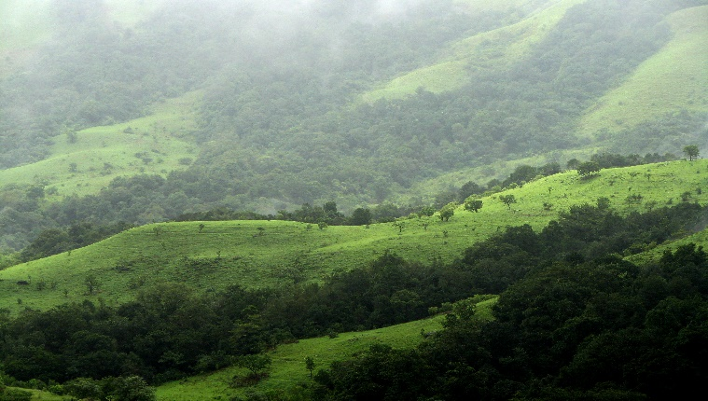

[This Photo](http://commons.wikimedia.org/wiki/file:shola_grasslands_and_forests_in_the_kudremukh_national_park,_western_ghats,_karnataka.jpg) by Unknown Author is licensed under [CC BY-SA](https://creativecommons.org/licenses/by-sa/3.0/)

One significant finding from the study is the altruistic nature of forest-adjacent communities, as revealed by their high willingness to pay for flood mitigation, showing that they are not just concerned with the private benefits accruing to them but also with the welfare of society. Overall, we found that there is much appreciation for the role of forest ecosystem services and that forest adjacent communities are generally pro-conservation. However, they would prefer medium-sized rather than large wildlife populations because of the potential of wildlife to damage crops.

Our findings can help government agencies design two kinds of policies: payments for ecosystem services (where a “buyer” who wants more of the service provided by the ecosystem pays a “seller” to conserve the ecosystem) and Participatory Forest Management (an existing arrangement where the government collaborates with the forest-adjacent communities to conserve forests). The information on willingness to pay can be used to inform the design of market-based incentives – for example, through increasing water tariffs to compensate forest- adjacent communities as an incentive to conserve forests. This can be achieved through partnership with private sector players.

There is also need to enhance the roll out, design and scale-up of participatory forest management in communities that have been reluctant to adopt the scheme. Policy makers also need to focus on options that have positive impacts on the livelihood of communities, in order to deepen community involvement in forest conservation.

Finally, a demonstration of the important of ecosystem services in commercial and agricultural production can increase environmental awareness and motivate forest-adjacent communities to conserve forest resources through participatory forest management.

*This brief is based on “Economic Valuation of Forest Ecosystem Services in Kenya:*

*Implications for Design of PES Schemes and Participatory Forest Management,” EfD Discussion Paper Series 21-04 (2021), by* *Boscow Okumu and Edwin Muchapondwa.*

**Contact:** Dr. Boscow Okumu, School of Economics, University of Cape Town, South Africa, kodhis2000@gmail.com

|  |  |
| --- | --- |
| logo_efd_cmyk | Environment for Development Initiative  [Www.efdinitiative.org](http://www.efdinitiative.org)  [Info@efdinitiative.org](mailto:info@efdinitiative.org)  University of Gothenburg  Gothenburg, Sweden |